SALES DATA ANALYSIS

A Data-Driven Analysis of Sales Performance,
Profitability and Business Trends

PROJECT REPORT

POTRISELVAN S

B.Tech – Artificial Intelligence
and Data Science
III Year

INDIVIDUAL PROJECT
Self-Developed Data Analytics Project

Academic Year
2026–2027

ABSTRACT
This project focuses on analyzing sales data to understand overall business performance and identify meaningful sales and profitability patterns. The dataset contains information related to orders, customers, products, regions, sales, profit, payment methods, customer satisfaction, and order status.
The data was cleaned and prepared using Microsoft Excel to improve data quality and consistency. SQL was used to perform structured queries and analyze sales, profit, products, categories, and regional performance. Python, using Pandas and Matplotlib, was used for exploratory data analysis and data visualization. An interactive Power BI dashboard was also developed to present key performance indicators and important business trends in an easy-to-understand format.
The analysis identified the highest-performing products, regions, and categories based on sales and profit. The project generated useful business insights that can help understand sales performance, identify profitable areas, and support data-driven decision-making.
Overall, this project demonstrates how Excel, SQL, Python, and Power BI can be combined to transform raw sales data into meaningful insights and an interactive business analysis solution.

- INTRODUCTION
Sales data analysis is an important process for understanding business performance and identifying patterns in sales, profit, products, regions, and customer behavior. Organizations generate large amounts of sales data through their daily transactions, and analyzing this data can help transform raw information into meaningful business insights.
The Sales Data Analysis project focuses on analyzing a sales dataset to understand overall business performance and identify important trends. The project includes data cleaning, exploratory data analysis, SQL-based analysis, and interactive dashboard development.
Microsoft Excel was used for data cleaning and initial analysis. SQL was used to perform queries for analyzing sales, profit, products, categories, and regions. Python libraries such as Pandas and Matplotlib were used for data processing, exploratory analysis, and visualization. Power BI was used to create an interactive dashboard containing key performance indicators, charts, and filters.
The final analysis provides insights into sales performance, profitability, product performance, and regional performance. These insights can help users understand business trends and support data-driven decision-making.

- PROBLEM STATEMENT
In a business environment, large volumes of sales transactions are generated every day through different products, customers, regions, payment methods, and order activities. Raw sales data contains valuable information about business performance, but it is often difficult to understand the important patterns and trends directly from the raw dataset. Without proper data processing and analysis, identifying high-performing products, profitable categories, strong sales regions, and overall business performance can be challenging.
The main problem addressed in this project is the lack of a systematic approach for transforming raw sales data into meaningful and understandable business information. The available sales dataset contains multiple attributes such as order details, customer information, product categories, product names, quantities, prices, discounts, sales amounts, profits, shipping costs, payment methods, customer satisfaction, and order status. Analyzing these attributes individually may not provide a clear overall view of the business performance.
Another important challenge is ensuring that the sales data is accurate and suitable for analysis. Raw datasets may contain duplicate records, missing values, inconsistent formats, incorrect data types, or other data quality issues. If such problems are not identified and handled properly, the results of the analysis may not accurately represent the underlying business information. Therefore, data cleaning and preprocessing are necessary before performing further analysis.
The project also addresses the challenge of analyzing sales information using different analytical techniques. Simple calculations may provide basic results, but they may not be sufficient to identify relationships and trends across products, categories, regions, sales, and profit. Therefore, SQL queries are used to retrieve and summarize relevant information, while Python is used for exploratory data analysis and visualization. These techniques provide different perspectives for understanding the dataset.
Another problem is the difficulty of presenting analytical results in a simple and interactive format. Business users may find it difficult to understand large tables of data or multiple analytical results without appropriate visualizations. Therefore, an interactive Power BI dashboard is developed to present key performance indicators, charts, trends, and filters in a user-friendly format. The dashboard allows users to explore sales and profit performance based on different business dimensions.
The project therefore aims to establish a complete data analysis workflow that starts from raw sales data and progresses through data cleaning, SQL analysis, Python-based exploratory data analysis, and Power BI visualization. The final objective is to convert raw sales records into meaningful insights that can help users understand business performance, identify important sales patterns, and support data-driven decision-making.

- OBJECTIVES
The main objective of this project is to analyze sales data and transform raw transactional information into meaningful business insights using data analytics techniques. The project focuses on understanding sales performance, profitability, product performance, regional performance, and other important business patterns.
The specific objectives of the Sales Data Analysis project are:
- To collect and understand the structure and characteristics of the sales dataset.
- To clean and preprocess the sales data by identifying missing values, duplicate records, inconsistent formats, and data quality issues.
- To perform initial data analysis using Microsoft Excel to understand the basic patterns and performance of the sales data.
- To use SQL queries for analyzing sales, profit, quantity, products, categories, regions, orders, and other important business metrics.
- To perform Exploratory Data Analysis (EDA) using Python and libraries such as Pandas and Matplotlib.
- To identify the highest-performing products, sales regions, and product categories based on sales and profit.
- To analyze sales and profit trends using appropriate charts and visualizations.
- To calculate important Key Performance Indicators (KPIs) such as total sales, total profit, total orders, total customers, and other relevant metrics.
- To develop an interactive Power BI dashboard for presenting sales performance and business insights through charts, KPIs, and filters.
- To identify meaningful business insights from the analyzed data and present them in a clear and understandable manner.
- To provide data-based recommendations that can help in understanding business performance and identifying potential areas for improvement.
- To demonstrate a complete data analytics workflow from raw data preparation to visualization and business reporting.

- DATASET DESCRIPTION
The dataset used in this project is a sales transaction dataset containing detailed information about orders, customers, products, sales performance, profitability, payment methods, customer satisfaction, and order status. The dataset provides multiple dimensions that can be used to analyze business performance from different perspectives.
The dataset contains 21 attributes covering order information, customer details, product information, financial values, shipping information, and customer-related information. The data was examined and prepared before performing SQL analysis, Python-based Exploratory Data Analysis (EDA), and Power BI visualization.
The main objective of using this dataset is to understand sales and profit performance across different products, categories, regions, and customers. The dataset also provides information such as quantity, unit price, discount percentage, shipping cost, customer satisfaction, return status, and order status, which can be used for further business analysis.
The dataset contains 2,961 unique orders and 2,922 unique customers. The analysis of the dataset resulted in a total sales value of 187,142,129.41 and a total profit of 35,281,079.32.
4.1 DATASET ATTRIBUTES
The major attributes available in the dataset are described below.
S.No. | Attribute | Description
1 | order_id | Unique identification number for each order
2 | order_date | Date on which the order was placed
3 | customer_id | Unique identification number of the customer
4 | customer_name | Name of the customer
5 | age | Age of the customer
6 | gender | Gender of the customer
7 | region | Geographical region of the order
8 | city | City associated with the customer or order
9 | product_category | Category of the purchased product
10 | product_name | Name of the purchased product
11 | quantity | Number of units purchased
12 | unit_price | Price of one unit of the product
13 | discount_pct | Discount percentage applied to the order
14 | sales_amount | Total sales value of the transaction
15 | profit | Profit generated from the transaction
16 | shipping_cost | Cost associated with shipping the order
17 | payment_method | Method used to complete the payment
18 | customer_satisfaction | Customer satisfaction score
19 | return_flag | Indicates whether the order was returned
20 | order_status | Current status of the order
21 | days_to_ship | Number of days taken to ship the order
The dataset provides sufficient information for performing descriptive analysis, comparative analysis, trend analysis, profitability analysis, and interactive business intelligence reporting.

Figure 4.1 — Dataset Preview: Part 1
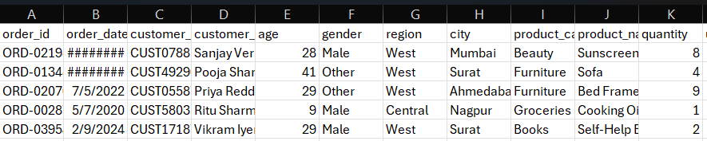
Figure 4.2 — Dataset Preview: Part 2
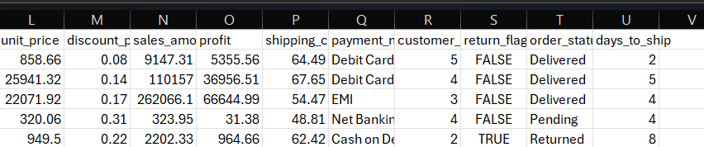

- TOOLS AND TECHNOLOGIES
The Sales Data Analysis project uses a combination of data analysis, database management, programming, spreadsheet, and business intelligence tools. Each technology is used for a specific stage of the project, starting from data cleaning and analysis to visualization and reporting.
5.1 MICROSOFT EXCEL
Microsoft Excel is used for initial data cleaning, data validation, and basic analysis. The dataset is checked for duplicate records, missing values, inconsistent formats, and incorrect data entries. Excel also provides functions and features that help in organizing and examining the sales data before further analysis.
5.2 MYSQL
MySQL is used for storing and querying the sales dataset. SQL queries are performed to calculate total sales, total profit, total quantity, and other business metrics. Grouping and sorting operations are also used to analyze sales performance across products, categories, and regions.
5.3 PYTHON
Python is used for data processing and Exploratory Data Analysis (EDA). It provides a flexible environment for analyzing large datasets and generating meaningful visualizations. Python is used to calculate important metrics and identify patterns in the sales data.
5.4 PANDAS
Pandas is a Python library used for data manipulation and analysis. It is used to load the dataset, inspect the data, perform grouping and aggregation operations, handle data types, and calculate sales and profit metrics.
5.5 MATPLOTLIB
Matplotlib is used to create graphical visualizations during the Python-based exploratory analysis. Bar charts and line charts are used to visualize sales by product, sales by region, sales by category, profit by category, and sales trends over time.
5.6 POWER BI
Microsoft Power BI is used to create an interactive business intelligence dashboard. The dashboard presents important Key Performance Indicators (KPIs), charts, filters, and sales trends. It provides an interactive way to explore sales and profit performance across different categories and regions.
5.7 TECHNOLOGY SUMMARY
S.No. | Technology | Purpose
1 | Microsoft Excel | Data cleaning and initial analysis
2 | MySQL | SQL-based data analysis
3 | Python | Data processing and EDA
4 | Pandas | Data manipulation and analysis
5 | Matplotlib | Data visualization
6 | Power BI | Interactive dashboard and reporting
These technologies together form a complete data analytics workflow, enabling the transformation of raw sales data into meaningful business insights and visual reports.

- DATA CLEANING AND PREPROCESSING
Data cleaning and preprocessing is an important step in the Sales Data Analysis project. Raw data may contain duplicate records, missing values, inconsistent formats, incorrect data types, and other data quality issues. Therefore, the dataset was examined and prepared before performing SQL analysis, Python Exploratory Data Analysis, and Power BI visualization.
6.1 DATA INSPECTION
The dataset was initially inspected to understand its structure, attributes, data types, and overall content. The column names, number of records, missing values, and duplicate records were checked before performing the cleaning process.
6.2 HANDLING DUPLICATE RECORDS
Duplicate records can affect the accuracy of sales calculations and business metrics. The dataset was checked for duplicate rows and unnecessary duplicate records were removed where applicable. This helped ensure that the same transaction was not counted more than once during analysis.
6.3 HANDLING MISSING VALUES
The dataset was examined for missing or blank values in different columns. Missing values were identified using data inspection techniques. The data was reviewed carefully to ensure that important sales, profit, product, customer, and order information was available for further analysis.
6.4 DATA FORMAT VALIDATION
The data types and formats of important attributes were checked and corrected where required. Date values were converted into an appropriate date format so that they could be used for time-based analysis. Numerical fields such as quantity, unit price, sales amount, profit, shipping cost, and discount percentage were checked to ensure that they were suitable for mathematical calculations.
6.5 TEXT DATA CLEANING
Text-based fields such as product names, customer names, regions, cities, and categories were reviewed for unnecessary spaces and inconsistent entries. Proper formatting was maintained to ensure that grouping and filtering operations produced accurate results.
6.6 NUMERICAL DATA VALIDATION
Numerical columns were checked to identify invalid or inappropriate values. Sales amount, profit, quantity, unit price, discount percentage, shipping cost, and customer satisfaction values were reviewed before performing analysis. This step helped improve the reliability of calculations and visualizations.
6.7 FINAL DATA VALIDATION
After the cleaning process, the dataset was checked again to ensure that it was suitable for further analysis. The cleaned data was then used for Excel analysis, SQL queries, Python-based Exploratory Data Analysis, and Power BI dashboard development.
The data cleaning and preprocessing stage helped improve data quality and provided a reliable foundation for the remaining stages of the Sales Data Analysis project.
Figure 6.1 → Raw Dataset : Part 1
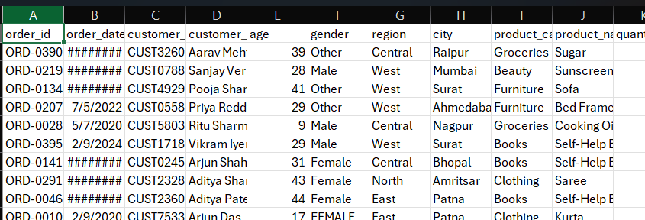
Figure 6.2 → Raw Dataset : Part 2
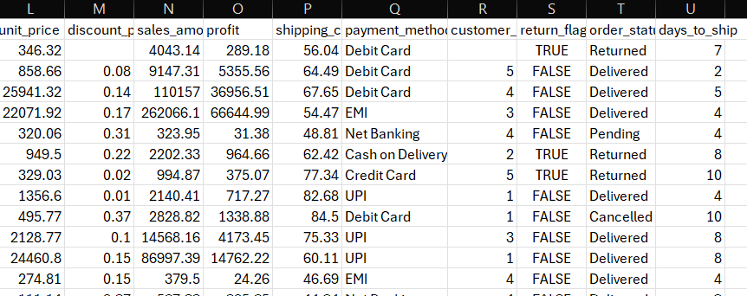

Figure 6.3 → Cleaned Dataset : Part 1
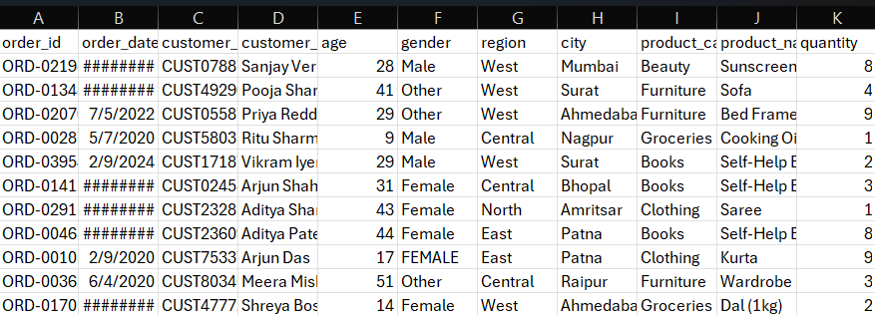
Figure 6.4 → Cleaned Dataset : Part 2
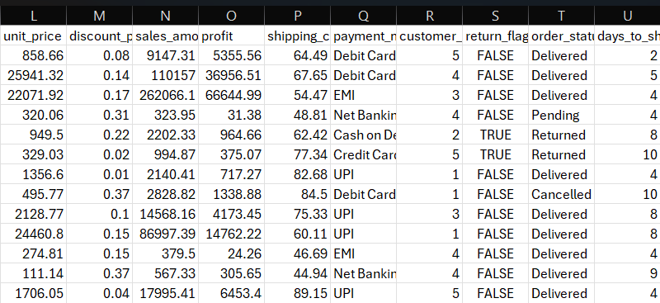

- EXCEL ANALYSIS
Microsoft Excel was used as one of the initial tools in the Sales Data Analysis project. Excel was mainly used for data cleaning, data validation, organization, and preliminary analysis before performing SQL analysis, Python-based Exploratory Data Analysis, and Power BI visualization.
7.1 DATA ORGANIZATION
The sales dataset was imported into Microsoft Excel and organized into a structured tabular format. Each row represents a sales transaction, while each column represents a specific attribute such as order details, customer information, product information, sales amount, profit, and other business-related information.
7.2 DATA CLEANING USING EXCEL
The dataset was examined in Excel to identify duplicate records, blank values, inconsistent formats, and data quality issues. Text fields were reviewed for unnecessary spaces and inconsistent entries. Date and numerical fields were also formatted appropriately to make the dataset suitable for further analysis.
7.3 DATA VALIDATION
Important numerical columns such as quantity, unit price, discount percentage, sales amount, profit, and shipping cost were checked to ensure that they contained valid values. Date fields were also checked and formatted correctly. These validation steps helped reduce errors during the subsequent analysis.
7.4 BASIC SALES METRICS
The cleaned dataset was used to understand the basic business performance. The main metrics considered in the project are presented below.
Table 7.1: Summary of Sales Metrics
Metric | Value
Total Sales | 187,142,129.41
Total Profit | 35,281,079.32
Total Orders | 2,961
Total Customers | 2,922
Highest Sales Product | Tablet
Highest Sales Region | South
Highest Sales Category | Electronics
Highest Profit Category | Electronics
The above metrics provide an initial understanding of the overall sales and profitability of the business. These values were further analyzed using SQL, Python, and Power BI to obtain more detailed insights.
Figure 7.1: Cleaned Sales Dataset in Excel

7.5 EXCEL ANALYSIS WORKFLOW
The Excel-based analysis followed a basic sequence of data preparation and validation. The workflow used in this project is shown below.
Table 7.2: Excel Analysis Activities
S.No. | Activity | Purpose
1 | Data Import | Load the sales dataset into Excel
2 | Data Inspection | Understand columns and data structure
3 | Duplicate Check | Identify repeated records
4 | Missing Value Check | Identify blank or missing entries
5 | Data Formatting | Correct date and numerical formats
6 | Data Validation | Verify important values and fields
7 | Basic Analysis | Understand sales and profit metrics
8 | Data Preparation | Prepare the dataset for further analysis
Figure 7.2: Excel Data Analysis / Summary
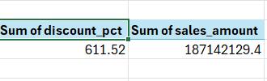
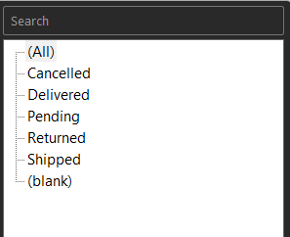
7.6 ROLE OF EXCEL IN THE PROJECT
Excel served as the first analytical stage of the project. It helped organize the dataset, identify data quality issues, validate important fields, and prepare the data for subsequent analysis. The cleaned and validated dataset was then used for SQL analysis, Python Exploratory Data Analysis, and Power BI dashboard development.
Overall, Excel provided a reliable foundation for the complete Sales Data Analysis workflow and helped ensure that the dataset was properly structured before applying advanced analytical techniques.

8. SQL ANALYSIS
SQL (Structured Query Language) was used in the Sales Data Analysis project to analyze the sales dataset and retrieve meaningful business information from the database. MySQL was used to perform queries for calculating important sales metrics and analyzing sales performance based on different business dimensions.
The SQL analysis helped in understanding total sales, total profit, quantity sold, product performance, category performance, and regional performance. Aggregation functions such as SUM() and AVG(), along with GROUP BY and ORDER BY clauses, were used to summarize and compare the sales data.
8.1 DATA IMPORT INTO MYSQL
The sales dataset was imported into MySQL and stored in a sales table. After importing the data, the table structure and available fields were checked before performing the analysis.
The SQL analysis followed these main steps:
- Import the sales dataset into MySQL.
- Verify the table structure and data.
- Calculate overall sales and profit.
- Analyze quantity sold.
- Analyze sales by product.
- Analyze sales by category.
- Analyze sales by region.
- Sort the results to identify high-performing areas.
8.2 TOTAL SALES ANALYSIS
The total sales value was calculated using the SUM() function. This query provides the overall sales generated from the available transactions.
SQL Query:
SELECT SUM(sales_amount) AS Total_Sales
FROM sales;Result:
Total Sales = 187,142,129.41
The result represents the overall sales value obtained from the analyzed sales data.
8.3 AVERAGE SALES ANALYSIS
The average sales value was calculated using the AVG() function. This helps understand the average sales value across the available transactions.
SQL Query:
SELECT AVG(Sales) AS Average_Sales
FROM sales;
The result provides an overall indication of the average sales value in the dataset.
8.4 TOTAL QUANTITY ANALYSIS
The total quantity of products sold was calculated using the SUM() function.
SQL Query:
SELECT SUM(Quantity) AS Total_Quantity
FROM sales;
This analysis helps understand the total number of product units sold through the recorded transactions.
8.5 SALES BY PRODUCT
Sales performance for individual products was analyzed by grouping the data based on the product name.
SQL Query:
SELECT product_name,
SUM(sales_amount) AS Total_Sales
FROM sales
GROUP BY product_name
ORDER BY Total_Sales DESC;
The query groups transactions by product and sorts the results in descending order of sales. This makes it possible to identify products that contribute significantly to overall sales.
From the analysis, Tablet recorded the highest sales among the products, with sales of 30,310,727.62.
8.6 SALES BY CATEGORY
Sales performance was also analyzed based on product categories.
SQL Query:
SELECT product_category,
SUM(sales_amount) AS Total_Sales
FROM sales
GROUP BY product_category
ORDER BY Total_Sales DESC;
The query calculates the total sales for each product category and sorts the categories from highest to lowest sales.
The analysis identified Electronics as the highest-selling product category, with total sales of 112,303,056.34.
8.7 SALES BY REGION
Regional sales performance was analyzed using the region field.
SQL Query:
SELECT region,
SUM(sales_amount) AS Total_Sales
FROM sales
GROUP BY region
ORDER BY Total_Sales DESC;
This query calculates the total sales generated by each region and helps identify regions with higher sales performance.
The analysis identified the South region as the highest-sales region, with total sales of 56,555,593.29.
8.8 SQL ANALYSIS SUMMARY
The major findings obtained from the SQL-based analysis are summarized below.
Table 8.1: SQL Analysis Summary
S.No. | Analysis | Result
1 | Total Sales | 187,142,129.41
2 | Total Profit | 35,281,079.32
3 | Total Orders | 2,961
4 | Total Customers | 2,922
5 | Highest Sales Product | Tablet
6 | Highest Sales Region | South
7 | Highest Sales Category | Electronics
8 | Highest Profit Category | Electronics
8.9 ROLE OF SQL IN THE PROJECT
SQL provided an efficient method for retrieving and summarizing information from the sales database. It helped convert transaction-level data into meaningful business metrics using aggregation, grouping, and sorting operations.
The results obtained through SQL were later compared with the Python analysis and presented through the Power BI dashboard. Therefore, SQL formed an important part of the overall data analytics workflow.
Figure 8.1: SQL Query Execution in MySQL Workbench
Insert a screenshot of your MySQL Workbench showing one or more completed queries and their output.
Figure 8.2: SQL Analysis Output
Insert a screenshot showing the result table of one of your important SQL queries, preferably Sales by Product, Sales by Category, or Sales by Region.

9. PYTHON EXPLORATORY DATA ANALYSIS (EDA)
Python was used in this project to perform Exploratory Data Analysis (EDA) on the cleaned sales dataset. Exploratory Data Analysis helps in understanding the structure of the data, identifying important patterns, calculating business metrics, and visualizing sales and profit performance.
The analysis was performed using Python in Google Colab/Jupyter Notebook. The Pandas library was used for data manipulation and aggregation, while Matplotlib was used to create visualizations.
9.1 DATASET LOADING
The cleaned sales dataset was loaded into Python using the Pandas library. The dataset was then inspected to understand its columns, data types, and overall structure.
The following Python libraries were used:
import pandas as pd
import matplotlib.pyplot as plt
The dataset was loaded using Pandas and stored in a DataFrame for further analysis.
9.2 DATASET INSPECTION
The dataset was inspected using functions such as head(), columns, shape, and info().
The dataset contains the following major attributes:
- Order information
- Customer information
- Product information
- Sales and profit information
- Shipping information
- Payment information
- Customer satisfaction
- Return and order status
This initial inspection helped understand the structure of the dataset before performing detailed analysis.
9.3 MISSING VALUE ANALYSIS
The dataset was checked for missing values using Pandas.
df.isnull().sum()
This step helped identify whether any columns contained missing values that could affect the analysis.
9.4 DUPLICATE RECORD ANALYSIS
Duplicate records were checked using the following command:
df.duplicated().sum()
Duplicate checking is important because repeated records may result in incorrect sales and profit calculations.
9.5 OVERALL BUSINESS METRICS
Important business metrics were calculated using Pandas aggregation functions.
The major metrics obtained from the analysis are shown below.
Table 9.1: Overall Business Metrics
Metric | Value
Total Sales | 187,142,129.41
Total Profit | 35,281,079.32
Total Orders | 2,961
Total Customers | 2,922
These metrics provide an overall view of the business performance represented by the dataset.
9.6 SALES BY PRODUCT
Sales performance was analyzed by grouping the data according to product name.
product_sales = df.groupby("product_name")["sales_amount"].sum().sort_values(ascending=False)
The resulting values were sorted in descending order to identify products with higher sales.
The analysis showed that Tablet recorded the highest sales among the products, with a total sales value of 30,310,727.62.
Figure 9.1: Sales by Product
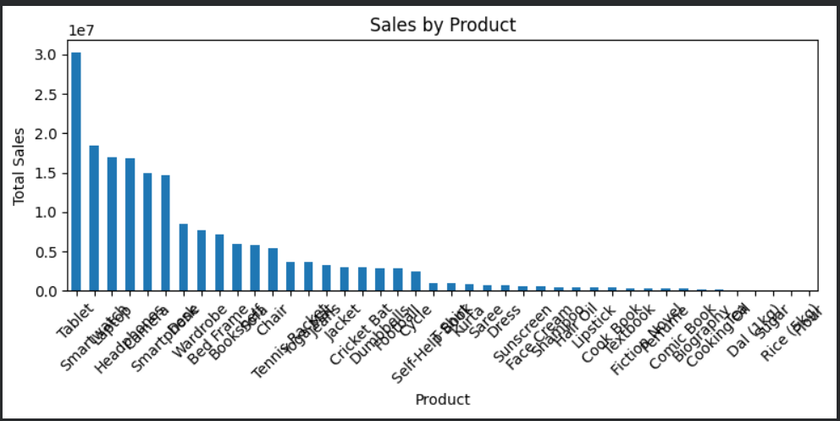
Insert the Python bar chart showing Sales by Product here.
9.7 SALES BY REGION
Regional sales performance was analyzed using the region column.
region_sales = df.groupby("region")["sales_amount"].sum().sort_values(ascending=False)
The analysis showed that the South region recorded the highest sales, with total sales of 56,555,593.29.
Figure 9.2: Sales by Region
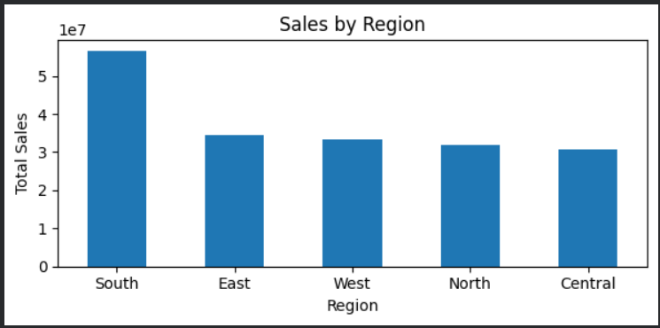
Insert the Python bar chart showing Sales by Region here.
9.8 SALES BY CATEGORY
Sales performance was also analyzed based on product category.
category_sales = df.groupby("product_category")["sales_amount"].sum().sort_values(ascending=False)
The analysis identified Electronics as the highest-selling category, with total sales of 112,303,056.34.
Figure 9.3: Sales by Category
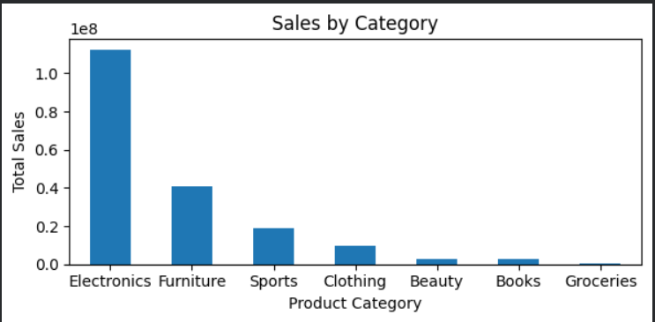
Insert the Python bar chart showing Sales by Category here.
9.9 PROFIT BY CATEGORY
Profit performance was analyzed by grouping the data according to product category.
category_profit = df.groupby("product_category")["profit"].sum().sort_values(ascending=False)
The analysis showed that Electronics generated the highest total profit, with a profit value of 14,010,168.86.
Figure 9.4: Profit by Category
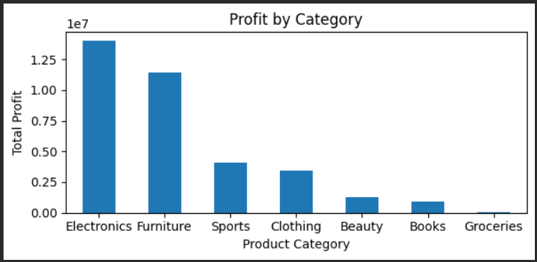
Insert the Python bar chart showing Profit by Category here.
9.10 SALES TREND ANALYSIS
The order date column was converted into a proper date format before performing time-based analysis.
df["order_date"] = pd.to_datetime(df["order_date"])

daily_sales = df.groupby("order_date")["sales_amount"].sum().reset_index()
The daily sales values were then visualized using a line chart. This visualization helps identify changes and patterns in sales over time.
Figure 9.5: Sales Trend Over Time
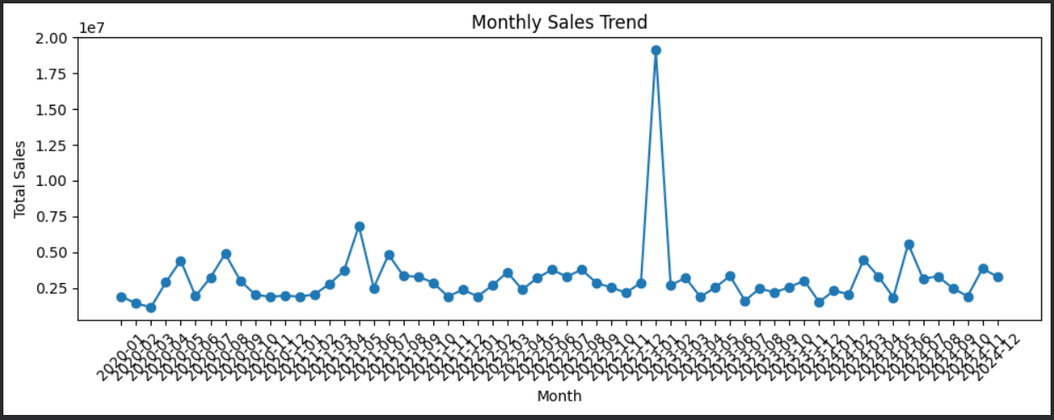
Insert the Python line chart showing the sales trend here.
9.11 PYTHON EDA SUMMARY
The major findings obtained from the Python-based Exploratory Data Analysis are summarized below.
Table 9.2: Python EDA Findings
S.No. | Analysis | Finding
1 | Total Sales | 187,142,129.41
2 | Total Profit | 35,281,079.32
3 | Total Orders | 2,961
4 | Total Customers | 2,922
5 | Highest Sales Product | Tablet
6 | Highest Sales Region | South
7 | Highest Sales Category | Electronics
8 | Highest Profit Category | Electronics
9.12 ROLE OF PYTHON IN THE PROJECT
Python provided a flexible environment for performing data analysis and visualization. Pandas was used for data manipulation, grouping, aggregation, and metric calculation, while Matplotlib was used to visualize important patterns.
The Python EDA results provided detailed analytical information that was later used to support the Power BI dashboard and identify the key business insights of the project.
Overall, Python helped transform the cleaned sales dataset into meaningful analytical results through statistical calculations and visual exploration.

10. POWER BI DASHBOARD
Microsoft Power BI was used in this project to develop an interactive dashboard for presenting the results of the Sales Data Analysis. The dashboard converts the analyzed sales data into an easy-to-understand visual format using Key Performance Indicators (KPIs), charts, and slicers.
The Power BI dashboard provides an overall view of sales performance, profitability, product performance, regional performance, and customer-related metrics. Users can interact with the dashboard by applying different filters and viewing the corresponding changes in the visualizations.
10.1 DATA IMPORT INTO POWER BI
The cleaned sales dataset was imported into Microsoft Power BI using the Get Data option. After importing the dataset, the columns and their data types were checked to ensure that the data was suitable for visualization.
The important fields used in the dashboard include:
- Order Date
- Region
- Product Category
- Product Name
- Quantity
- Sales Amount
- Profit
- Customer Satisfaction
- Payment Method
- Order Status
- Gender
10.2 DASHBOARD KPIs
Key Performance Indicators (KPIs) were created to provide a quick summary of the overall business performance.
Table 10.1: Dashboard KPIs
KPI | Value
Total Sales | 187,142,129.41
Total Profit | 35,281,079.32
Total Orders | 2,961
Total Customers | 2,922
Total Quantity | Based on dataset
Average Satisfaction | Based on dataset
The KPI cards allow users to understand the major business metrics without examining individual records.
10.3 SALES BY CATEGORY
A chart was created to compare sales performance across different product categories.
The visualization helps identify categories that contribute significantly to overall sales. From the analysis, Electronics recorded the highest category sales with 112,303,056.34.
Figure 10.1: Sales by Category
Insert the Power BI Sales by Category chart screenshot here.
10.4 SALES BY REGION
A regional sales visualization was created to compare the sales performance of different regions.
The analysis showed that the South region recorded the highest sales with 56,555,593.29.
Figure 10.2: Sales by Region
Insert the Power BI Sales by Region chart screenshot here.
10.5 SALES TREND
A sales trend visualization was included to analyze sales performance over time. The Order Date field was used as the time dimension and Sales Amount was used as the measure.
This visualization helps users observe changes in sales performance across different dates or periods.
Figure 10.3: Sales Trend
Insert the Power BI Sales Trend chart screenshot here.
10.6 PROFIT ANALYSIS
Profit performance was visualized to understand the contribution of different product categories to overall profitability.
Electronics generated the highest total profit among the product categories, with a total profit of 14,010,168.86.
Figure 10.4: Profit by Category
Insert the Power BI Profit by Category chart screenshot here.
10.7 PRODUCT PERFORMANCE
A product-level visualization was included to compare sales performance among individual products.
The analysis identified Tablet as the highest-selling product, with total sales of 30,310,727.62.
Figure 10.5: Sales by Product
Insert the Power BI Sales by Product chart screenshot here.
10.8 SLICERS AND FILTERS
Interactive slicers were added to allow users to filter the dashboard based on different business dimensions.
The main slicers used in the dashboard include:
S.No. | Slicer | Purpose
1 | Region | Filter sales by geographical region
2 | Product Category | Filter data by category
3 | Gender | Analyze sales based on gender
4 | Payment Method | Analyze different payment methods
5 | Order Status | Filter orders based on status
6 | Order Date | Analyze sales for a selected date range
These slicers make the dashboard interactive and allow users to explore specific portions of the dataset.
10.9 DASHBOARD DESIGN
The dashboard was designed using a clean and professional layout. KPI cards were positioned prominently to provide quick access to important business metrics. Charts were arranged to provide comparisons between products, categories, regions, and time periods.
A light-themed visual design with rounded cards, soft background elements, and clear chart formatting was used to improve readability and presentation. Different visual elements were organized in a structured manner so that users can easily understand the information presented in the dashboard.
10.10 INTERACTIVE DASHBOARD
The completed Power BI dashboard combines KPIs, charts, and slicers into a single interactive reporting interface. When a user selects a slicer value, the relevant charts and KPI values update according to the selected filter.
Figure 10.6: Complete Power BI Sales Dashboard
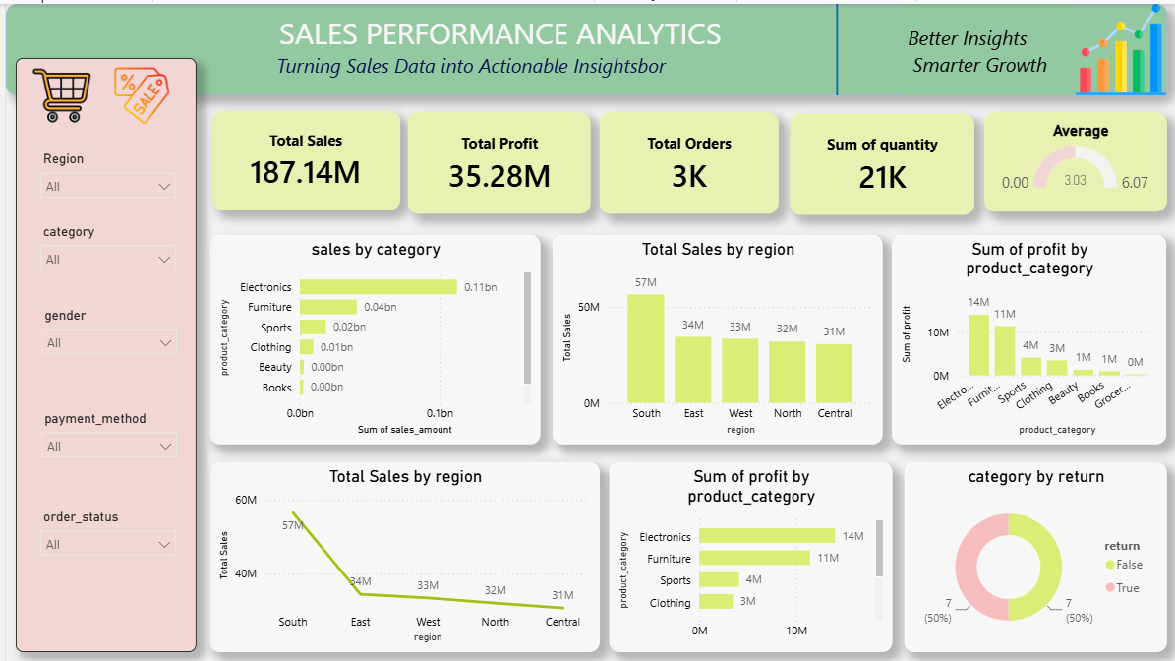
Insert a full screenshot of your completed Power BI dashboard here.
The dashboard provides a consolidated view of the sales data and helps users understand business performance without manually examining the complete dataset.
10.11 ROLE OF POWER BI IN THE PROJECT
Power BI played an important role in converting the analytical results into an interactive business intelligence report. The dashboard provides a visual representation of sales, profit, products, categories, regions, and other important business metrics.
The Power BI dashboard therefore acts as the final visualization layer of the Sales Data Analysis project, connecting the results obtained from data cleaning, SQL analysis, and Python Exploratory Data Analysis with an interactive reporting interface.
Figure 10.7 — Interactive Dashboard with Region Filter
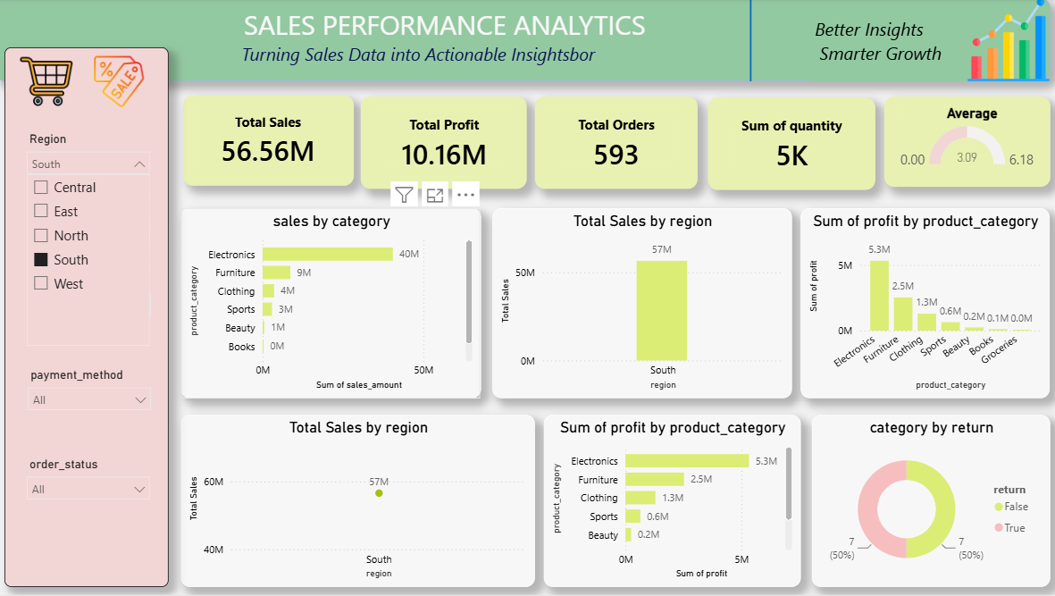

11. KEY PERFORMANCE INDICATORS (KPIs)
Key Performance Indicators (KPIs) are important measurable values used to understand the overall performance of a business. In this project, KPIs were used to summarize the major results obtained from the Sales Data Analysis and present them in a simple and understandable format.
The KPIs were calculated from the sales dataset and displayed in the Power BI dashboard using KPI cards. These indicators provide a quick overview of sales, profitability, orders, customers, and customer-related performance.
11.1 TOTAL SALES
Total Sales represents the overall revenue generated from the sales transactions available in the dataset.
Total Sales = 187,142,129.41
This KPI provides an overall measurement of the sales value generated during the analyzed period.
11.2 TOTAL PROFIT
Total Profit represents the overall profit generated from the analyzed sales transactions.
Total Profit = 35,281,079.32
This KPI helps understand the overall profitability of the business.
11.3 TOTAL ORDERS
Total Orders represents the number of unique orders recorded in the dataset.
Total Orders = 2,961
This KPI provides an indication of the transaction volume handled by the business.
11.4 TOTAL CUSTOMERS
Total Customers represents the number of unique customers available in the dataset.
Total Customers = 2,922
This metric helps provide an overview of the customer base represented in the sales data.
11.5 TOTAL QUANTITY
Total Quantity represents the total number of product units sold through the recorded transactions.
This KPI was calculated by aggregating the quantity field from the dataset.
DAX Measure:
Total Quantity = SUM('Sales'[quantity])
The resulting value is displayed in the Power BI dashboard as a KPI card.
11.6 AVERAGE CUSTOMER SATISFACTION
Average Customer Satisfaction represents the average satisfaction score recorded for customers.
This KPI provides an overview of customer satisfaction across the available transactions.
DAX Measure:
Average Satisfaction = AVERAGE('Sales'[customer_satisfaction])
The result is displayed in the Power BI dashboard to provide a quick view of customer satisfaction.
11.7 KPI SUMMARY
The major KPIs used in the project are summarized below.
Table 11.1: Key Performance Indicators
S.No. | KPI | Result / Measurement
1 | Total Sales | 187,142,129.41
2 | Total Profit | 35,281,079.32
3 | Total Orders | 2,961
4 | Total Customers | 2,922
5 | Total Quantity | 21390
6 | Average Customer Satisfaction | 3.03
11.8 KPI VISUALIZATION IN POWER BI
The KPIs were displayed as separate cards at the top of the Power BI dashboard. This arrangement allows users to understand the overall business performance immediately after opening the dashboard.
Figure 11.1: KPI Cards in Power BI Dashboard
Insert a screenshot showing the KPI cards from your Power BI dashboard here.
The KPI cards provide a concise summary of the most important business measurements and make the dashboard easier to understand and use.
11.9 IMPORTANCE OF KPIs
KPIs help convert large amounts of transactional data into a small number of meaningful measurements. In this project, the KPIs provide information about overall sales, profitability, transaction volume, customer base, quantity sold, and customer satisfaction.
These indicators can be used together with the dashboard charts and slicers to examine business performance from different perspectives.

12. KEY FINDINGS AND BUSINESS INSIGHTS
The Sales Data Analysis project was performed using Excel, SQL, Python, and Power BI to understand the overall business performance and identify important patterns in the sales data. The analysis produced several meaningful findings related to sales, profit, products, categories, and regions.
The major findings obtained from the analysis are presented below.
12.1 OVERALL SALES PERFORMANCE
The total sales generated from the analyzed dataset were 187,142,129.41. This value represents the overall sales amount obtained from the recorded transactions.
The total profit generated from the analyzed sales data was 35,281,079.32. These values provide an overall view of the sales and profitability represented in the dataset.
12.2 HIGHEST-SELLING PRODUCT
The product-level analysis showed that Tablet recorded the highest sales among the products.
Tablet Sales = 30,310,727.62
This indicates that Tablet contributed a significant amount to the overall sales value in the analyzed dataset.
12.3 HIGHEST-PERFORMING REGION
The regional analysis showed that the South region recorded the highest sales.
South Region Sales = 56,555,593.29
The result indicates that the South region contributed the largest sales value among the regions represented in the dataset.
12.4 HIGHEST-SELLING CATEGORY
The category-level analysis identified Electronics as the highest-selling product category.
Electronics Sales = 112,303,056.34
This shows that Electronics contributed a substantial portion of the total sales generated in the dataset.
12.5 HIGHEST-PROFIT CATEGORY
The profit analysis showed that Electronics also generated the highest total profit among the product categories.
Electronics Profit = 14,010,168.86
This finding provides information about the contribution of the Electronics category to overall profitability.
12.6 ORDER AND CUSTOMER ANALYSIS
The analysis identified 2,961 unique orders and 2,922 unique customers in the dataset.
These metrics provide an overview of the transaction volume and customer base represented by the analyzed sales records.
12.7 BUSINESS INSIGHTS SUMMARY
The major findings are summarized below.
Table 12.1: Key Business Insights
S.No. | Business Area | Finding
1 | Total Sales | 187,142,129.41
2 | Total Profit | 35,281,079.32
3 | Highest Sales Product | Tablet
4 | Tablet Sales | 30,310,727.62
5 | Highest Sales Region | South
6 | South Region Sales | 56,555,593.29
7 | Highest Sales Category | Electronics
8 | Electronics Sales | 112,303,056.34
9 | Highest Profit Category | Electronics
10 | Electronics Profit | 14,010,168.86
11 | Unique Orders | 2,961
12 | Unique Customers | 2,922
12.8 ANALYTICAL INTERPRETATION
The analysis shows that product, regional, and category-level performance varies across the dataset. Tablet was the highest-selling individual product, while Electronics was the highest-performing category in terms of both sales and profit.
The South region recorded the highest sales among the analyzed regions. This provides a useful area for further examination of product demand, customer characteristics, and sales distribution.
The combination of SQL results, Python visualizations, and Power BI dashboard analysis provides a consistent view of the major sales patterns in the dataset.
12.9 VISUAL SUMMARY
The major findings were also represented through charts in Python and Power BI. These visualizations make it easier to compare products, categories, and regions and provide a clear representation of the analytical results.
Figure 12.1: Business Insights Dashboard
Insert a suitable screenshot of your Power BI dashboard highlighting the major KPI cards and charts here.
The findings obtained from the analysis provide the foundation for developing data-based recommendations for improving the understanding and monitoring of business performance.

13. BUSINESS RECOMMENDATIONS
Based on the findings obtained from Excel, SQL, Python Exploratory Data Analysis, and Power BI, several data-based recommendations can be identified. These recommendations focus on understanding sales performance, product performance, regional performance, profitability, and customer-related metrics.
13.1 FOCUS ON HIGH-PERFORMING PRODUCTS
The analysis identified Tablet as the highest-selling product, with sales of 30,310,727.62. Products with strong sales performance can be monitored regularly to understand their demand and contribution to overall revenue.
Sales trends, customer demand, and product performance can be analyzed periodically to support inventory and sales planning.
13.2 ANALYZE SOUTH REGION PERFORMANCE
The South region recorded the highest sales, with 56,555,593.29 in sales.
The business can further analyze the factors contributing to this performance, such as product demand, customer distribution, pricing, and order volume. Similar patterns can also be examined in other regions to understand differences in regional performance.
13.3 MONITOR ELECTRONICS CATEGORY
The Electronics category recorded the highest sales of 112,303,056.34 and the highest total profit of 14,010,168.86.
The performance of this category should be monitored regularly using sales and profit indicators. Product-level analysis within the category can also help identify the products contributing to its overall performance.
13.4 MONITOR LOW-PERFORMING PRODUCTS AND CATEGORIES
Along with identifying high-performing products, it is important to monitor products and categories with comparatively lower sales or profit.
Detailed analysis of low-performing products can help identify possible factors such as lower demand, pricing differences, discounts, or customer preferences. This information can support future product and sales planning.
13.5 USE REGULAR SALES MONITORING
The Power BI dashboard can be used for regular monitoring of sales and profit performance. KPI cards, charts, and slicers provide an interactive method for examining business performance across different dimensions.
Regular monitoring can help users identify changes in sales, regional performance, product performance, and profitability over time.
13.6 MONITOR CUSTOMER SATISFACTION
Customer satisfaction is an important metric available in the dataset. The average customer satisfaction value can be monitored along with sales and profit performance.
Comparing customer satisfaction with product, region, and order information can provide additional insights into customer-related patterns.
13.7 SUPPORT DATA-DRIVEN DECISION-MAKING
The analysis demonstrates the importance of using data to understand business performance. Instead of relying only on manual observation, organizations can use SQL analysis, Python EDA, and Power BI dashboards to monitor important business metrics.
A structured analytics workflow can help decision-makers access relevant information and examine business performance from multiple perspectives.
13.8 RECOMMENDATION SUMMARY
The major recommendations are summarized below.
Table 13.1: Business Recommendations
S.No. | Recommendation | Purpose
1 | Monitor high-performing products | Understand and maintain strong product performance
2 | Analyze South region performance | Understand factors contributing to regional sales
3 | Monitor Electronics category | Track its sales and profit contribution
4 | Review low-performing products | Identify areas requiring further analysis
5 | Use Power BI for regular monitoring | Track KPIs and trends interactively
6 | Monitor customer satisfaction | Understand customer-related patterns
7 | Support data-driven decisions | Improve business analysis and reporting
These recommendations are based on the patterns identified from the analyzed dataset and can be used as areas for further business investigation.

14. CONCLUSION
The Sales Data Analysis project successfully demonstrated a complete data analytics workflow for transforming raw sales data into meaningful business information. The project covered multiple stages, including data cleaning, data validation, Excel analysis, SQL analysis, Python-based Exploratory Data Analysis, and Power BI dashboard development.
Microsoft Excel was used to organize, clean, and validate the dataset. MySQL was used to perform SQL-based analysis and calculate important business metrics. Python, particularly Pandas and Matplotlib, was used to perform Exploratory Data Analysis and create visualizations for identifying important patterns and trends.
The analysis identified several important findings from the sales data. The total sales were 187,142,129.41, while the total profit was 35,281,079.32. The analysis recorded 2,961 unique orders and 2,922 unique customers. Among the products, Tablet recorded the highest sales with 30,310,727.62. The South region recorded the highest sales with 56,555,593.29. The Electronics category recorded the highest sales with 112,303,056.34 and also generated the highest total profit of 14,010,168.86.
The Power BI dashboard brought the analytical results together into an interactive visual reporting interface. KPI cards, charts, and slicers were used to provide an easy-to-understand view of sales, profit, products, categories, regions, and other business metrics.
Overall, the project demonstrates how data analytics tools can be combined to analyze sales data and convert raw transactional records into useful business insights. The complete workflow provides practical experience in data cleaning, database querying, exploratory analysis, visualization, and business intelligence reporting.
The project also demonstrates the importance of data-driven analysis in understanding business performance. The developed analytical workflow and Power BI dashboard can serve as a foundation for further analysis and future improvements.

15. FUTURE SCOPE
The Sales Data Analysis project provides a basic and practical framework for analyzing sales performance using Excel, SQL, Python, and Power BI. The project can be further enhanced by applying advanced data analytics, automation, machine learning, and real-time business intelligence techniques.
15.1 SALES FORECASTING
Future versions of the project can include sales forecasting techniques to estimate future sales based on historical sales patterns. Time-series analysis and machine learning algorithms can be used to identify future sales trends.
15.2 CUSTOMER SEGMENTATION
Customer segmentation can be added to classify customers based on characteristics such as purchase behavior, spending patterns, order frequency, and satisfaction levels.
Techniques such as clustering can be used to identify different customer groups and understand their behavior.
15.3 PRODUCT RECOMMENDATION
A recommendation system can be developed to suggest products based on customer purchase history and product preferences. This can provide an additional analytical layer for understanding customer-product relationships.
15.4 ADVANCED POWER BI FEATURES
The Power BI dashboard can be further enhanced using advanced features such as:
- Drill-through reports
- Tooltips
- Bookmarks
- Dynamic titles
- Advanced DAX measures
- Interactive navigation
- Additional filtering options
These features can make the dashboard more interactive and useful for detailed business analysis.
15.5 AUTOMATED DATA REFRESH
The project can be extended to support automated data refresh. Instead of manually importing updated datasets, the dashboard can be connected to a database or cloud-based data source so that new sales information can be updated automatically.
15.6 REAL-TIME SALES ANALYTICS
A future version can integrate real-time or near-real-time sales data. This would allow users to monitor sales performance, order activity, and other business metrics as new transactions are recorded.
15.7 CLOUD DATA ANALYTICS
The project can be extended by using cloud platforms and data services such as AWS, Microsoft Azure, or Google Cloud. Cloud-based storage and processing can support larger datasets and scalable analytics workflows.
15.8 MACHINE LEARNING INTEGRATION
Machine learning models can be incorporated to perform advanced tasks such as sales prediction, customer segmentation, product demand prediction, and identification of unusual sales patterns.
15.9 FUTURE SCOPE SUMMARY
The future development possibilities of the project are summarized below.
Table 15.1: Future Development Areas
S.No. | Future Enhancement | Purpose
1 | Sales Forecasting | Estimate future sales trends
2 | Customer Segmentation | Identify different customer groups
3 | Product Recommendation | Suggest relevant products
4 | Advanced Power BI | Improve dashboard interactivity
5 | Automated Refresh | Reduce manual data updates
6 | Real-Time Analytics | Monitor current business activity
7 | Cloud Analytics | Support scalable data processing
8 | Machine Learning | Perform advanced predictive analysis
The future enhancements can transform the current project from a descriptive sales analysis system into a more advanced business analytics and decision-support solution.

16. REFERENCES
The following resources were referred to for understanding the tools, programming libraries, database concepts, data analysis techniques, and business intelligence features used in this project.
16.1 SOFTWARE AND DOCUMENTATION REFERENCES
- Microsoft Excel – Microsoft Office documentation and spreadsheet features used for data cleaning, organization, and analysis.
- MySQL – MySQL documentation and SQL reference for database management and query execution.
- Python – Python documentation for programming and data analysis.
- Pandas – Pandas documentation for data manipulation, data cleaning, grouping, aggregation, and analysis.
- Matplotlib – Matplotlib documentation for creating charts and visualizations.
- Microsoft Power BI – Microsoft documentation for dashboard development, data visualization, Power Query, and DAX.
16.2 DATA ANALYSIS REFERENCES
- Python-based Exploratory Data Analysis concepts and techniques were used to inspect, summarize, and visualize the sales dataset.
- SQL aggregation, grouping, filtering, and sorting concepts were used for analyzing sales and business performance.
- Data visualization principles were applied to present sales, profit, product, category, regional, and trend-based information.
16.3 PROJECT RESOURCES
- The sales dataset used in this project was processed and analyzed as part of the Sales Data Analysis project.
- The Python analysis was performed using Google Colab/Jupyter Notebook.
- The SQL analysis was performed using MySQL Workbench.
- The final interactive dashboard was developed using Microsoft Power BI.
These resources supported the development of the complete Sales Data Analysis workflow, from data preparation and analysis to visualization and business reporting.

